[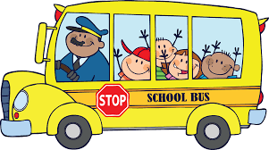](https://www.google.co.uk/url?sa=i&rct=j&q=&esrc=s&source=images&cd=&cad=rja&uact=8&ved=0ahUKEwjpmPbk69HJAhUBERQKHQCHBocQjRwIBw&url=http://www.clipartbest.com/free-clip-art-of-bus-for-children&bvm=bv.109395566,d.d24&psig=AFQjCNGcif9he8lLt_UukJBT3C8VY6IwKA&ust=1449855761379828)



**Mathematics**

**We will be...**

* Place Value to 50
* learning the number bonds to 5 and 10 and the related number facts
* Adding and Subtracting numbers to 20 using visual resources such as number lines
* Learning to count in 2’s, 5’s and 10’s
* Finding ‘one less’ than a given number to 10 and representing zero
* Comparing numbers to 5
* Comparing sets of objects and saying whether they are equal or not
* Exploring measure- capacity and mass
* Learning to name and identify 2D and 3D shapes

**Physical Development**

**PE**

**We will be...**

* Practising getting changed for PE independently
* Developing our gross motors skills and negotiating space safely
* Developing ball skills- rolling, aiming and throwing
* Dance- responding to a piece of music
* Discussing the changes to our bodies after exercise
* Discussing the importance of staying active and exercising and trying lots of healthy snacks.
* Enhancing our fine motor control through threading, cutting, writing and drawing activities
* Using a range of tools when using malleable materials such as play dough and clay

**Cherry, Ash & Oak Tree: TERM 3/ 4, 2022**

***(Specific Year 1 objectives)*** 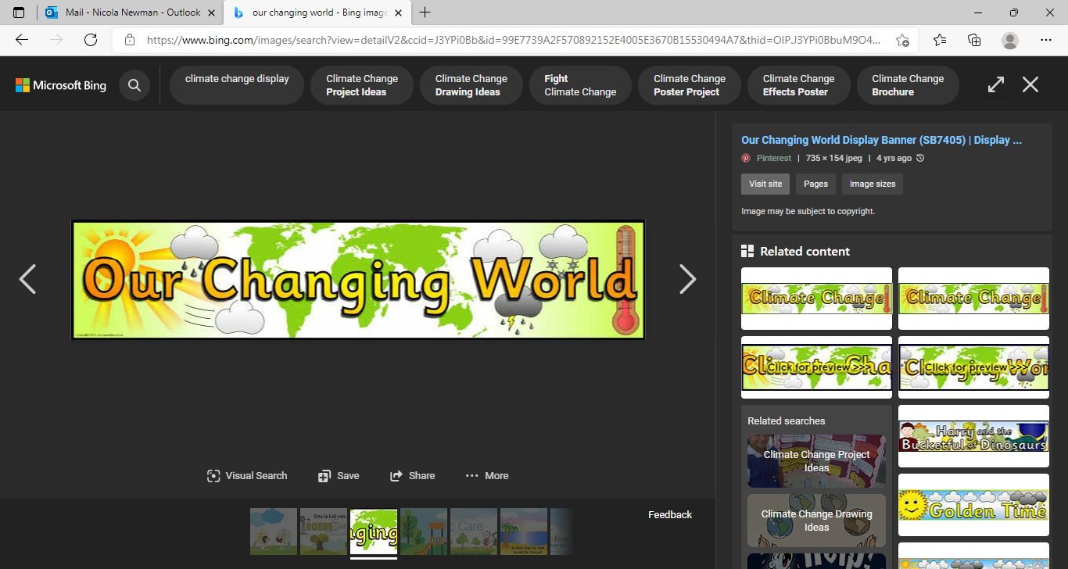

**Term 3 & 4: 2022**

**Expressive Arts and Design**

**Art and Design Technology**

**We will be...**

* Designing and making a puppet
* Communicating our ideas through talking and drawing
* Selecting from and using a range of tools and equipment to perform practical tasks (for example, cutting, shaping, joining and finishing.)
* Evaluating our ideas and products against the original design criteria.

**Forest School**

**We will be...**

* Looking at the changes that happen as we move through each season
* Foraging for objects to make shapes (2D and 3D)
* Constructing small structures/ fairy houses using natural resources
* Use natural resources to make puppets and tell stories with these
* Exploring Biodiversity

**Personal, Social and Emotional development Personal, Social, Health and Economic**

**We will be…**

* Taking part in the NSPCC ‘PANTS’ lesson
* Celebrating similarities and differences between people in my class and discussing ways in which I am the same/ different as my friends
* Learning about our dreams and goals
* Discussing what bullying is and understand how being bullied might feel.
* Discussing who the people are that we can talk to if we are feeling unhappy or being bullied.
* Discussing how we can make friends and what it feels like to be friendly.

**Education for Social Responsibility (ESR)**

* To understand how climate change affects the weather
* To identify some of the effects of climate change.
* To investigate some alternative energy sources.

**Understanding the World**

**Science/ History/ Geography/ RE**

**We will be...**

**Science**

* Looking at seasonal changes- What happens in Spring?
* Investigating materials and their properties

**History**

* Thinking about space and focusing on space men and women, in particular; Neil Armstrong and Jeannette Epps

**Geography**

* Looking at the UK and how London is different from China
* Looking at the different types of transport, comparing transport and identifying different routes taken by a range of transports

**RE**

* Thinking about places that are special and why they are special. To understand that a church is a holy building for Christians and a Mosque is a religious building, where Muslims pray.

**Literacy**

**We will be...**

* Learning to recognise and write my name
* Making marks using crayon, chalk, pencil, paint and explain what they say/ mean
* Taking part in ‘Phase 3’ and **‘Phase 5’** Storytime phonic sessions- learning the sounds that different letters make
* Segmenting and blending words when reading
* Poetry- Inspired by Winter
* Fairy Tales- story maps, exploring settings and characters
* Fact Files- Space

**Communication and Language**

**Speaking and Listening**

**We will be...**

* Learning to talk about ourselves using words such as tall, short etc.
* Imagining and recreating roles in the home role play area
* Asking questions to get to know our new friends
* Talking about our family and why they are special to us
* Thinking about sequence of events in stories and saying what happened in the beginning, middle and end.
* Singing songs
* Discussing what good listening looks like
* Following instructions and directions
* Asking and answering questions

[](https://www.google.co.uk/url?sa=i&rct=j&q=&esrc=s&source=images&cd=&cad=rja&uact=8&ved=0ahUKEwjpmPbk69HJAhUBERQKHQCHBocQjRwIBw&url=http://www.clipartbest.com/free-clip-art-of-bus-for-children&bvm=bv.109395566,d.d24&psig=AFQjCNGcif9he8lLt_UukJBT3C8VY6IwKA&ust=1449855761379828)