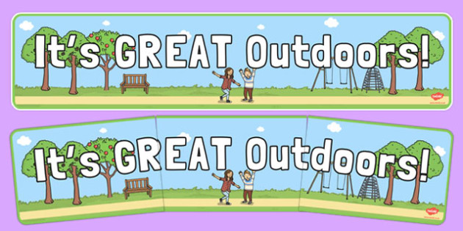[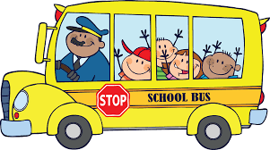](https://www.google.co.uk/url?sa=i&rct=j&q=&esrc=s&source=images&cd=&cad=rja&uact=8&ved=0ahUKEwjpmPbk69HJAhUBERQKHQCHBocQjRwIBw&url=http://www.clipartbest.com/free-clip-art-of-bus-for-children&bvm=bv.109395566,d.d24&psig=AFQjCNGcif9he8lLt_UukJBT3C8VY6IwKA&ust=1449855761379828)

**Mathematics**

**We will be...**

* Securing our knowledge of the numbers to 10 including the composition of each
* Subitising (recognise quantities without counting) up to 5
* Recalling the number bonds to 5, 10 and extending to 20
* Learning some double number facts to 10+ 10
* Counting beyond 20 and comparing quantities
* Using number tracks/ number lines to add and subtract
* Exploring weight/ mass, height/ length, volume/ capacity
* Measuring and comparing the size of objects and using the associated language such as longer, shorter, taller, heavier, lighter.
* Geometry- explore position and direction
* Fractions- halves and quarters

**Education for Social Responsibility (ESR)**

* To explore the variety of plants and animals found in the local area.
* To explore how plants and animals are linked.
* To be able to plan and create a bug hotel.

**Expressive Arts and Design**

**Art and Design Technology**

**We will be...**

* Looking at the story Leaf Man and creating our own pieces of art using natural materials
* Food- Design a healthy picnic
* Identify which foods are healthy and those we should eat in moderation
* Learn about food hygiene and how to prepare food safely- using equipment to chop, slice, peel

**Literacy**

**We will be...**

* Retelling stories using story maps, puppets and small world toys
* Segmenting and blending words when reading with more independence
* Write recognisable letters, most of which are correctly formed
* Spell words by identifying sounds in them and representing the sounds with a letter or letters
* Write simple phrases and sentences that can be read by others
* Poetry- Inspired by Spring
* Non-fiction texts – Looking at the features of leaflets/booklets
* Writing non- chronological reports based on our school
* Writing fact files about animals
* Poetry- Riddles



**Understanding the World**

**Science/ History/ Geography**

**We will be...**

**Science: Plants and Seasonal Changes**

* To identify signs of Spring/ Summer- observe seasonal and daily weather patterns
* To describe and compare plants, seeds and bulbs.
* To name the basic parts of a plant.
* To plant seeds and to make observations of how they grow over time.
* To name and compare the parts of plants.
* To identify and name some common garden and wild plants and trees.

**History:**

* Look at how transport has changed over time
* Who are Bessie Coleman and Richard Jefferies?

**Geography:**

* Using photos to identify landmarks, human and physical features.
* Maps- Creating aerial views of the school and surrounding area.

**Cherry, Ash & Oak Tree: TERM 5/ 6, 2022**

***(Specific Year 1 objectives)***

**Forest School**

**We will be exploring…**

* Den building
* Using tools safely to make a bug hotel
* Flowers, art and bees

**Communication and Language Speaking and Listening**

**We will be…**

* Participating in small group, class and one-to-one discussions, offering our own ideas
* Express their ideas and feelings about their experiences using full sentences, including use of past, present and future tenses
* Listen attentively and respond to what they hear with relevant questions, comments and actions

**Religious Education- Where do we belong? What is special about the World?**

**We will be thinking about…**

* What makes us feel special? What makes Christians feel special to God? How do Christians know that children are special to God?
* What groups do we belong to?
* Exploring how babies are welcomed into different religions
* What are our favourite things about nature?
* Why do some people say the world is special?
* Christianity- The Creation story
* Islam- What stories do Muslims tell about Gods creation?
* Is our world ‘very good’?

**Personal, Social and Emotional development Personal, Social, Health and Economic- Changing Me**

**We will be…**

* Discussing how we have changed since we were babies
* Discussing how we feel about things changing in our lives and how we can manage our feelings
* Naming the body parts correctly including the parts that make girls and boys different

**Physical Development**

**PE**

**We will be...**

* Continue getting changed for PE independently
* Developing our gross motors skills and negotiating space safely
* Developing ball skills- rolling, aiming and throwing
* Dance- responding to a piece of music
* Discussing the changes to our bodies after exercise
* Discussing the importance of staying active and exercising and trying lots of healthy snacks.
* Enhancing our fine motor control through threading, cutting, writing and drawing activities
* Using a range of tools when using malleable materials such as play dough and clay

[](https://www.google.co.uk/url?sa=i&rct=j&q=&esrc=s&source=images&cd=&cad=rja&uact=8&ved=0ahUKEwjpmPbk69HJAhUBERQKHQCHBocQjRwIBw&url=http://www.clipartbest.com/free-clip-art-of-bus-for-children&bvm=bv.109395566,d.d24&psig=AFQjCNGcif9he8lLt_UukJBT3C8VY6IwKA&ust=1449855761379828)