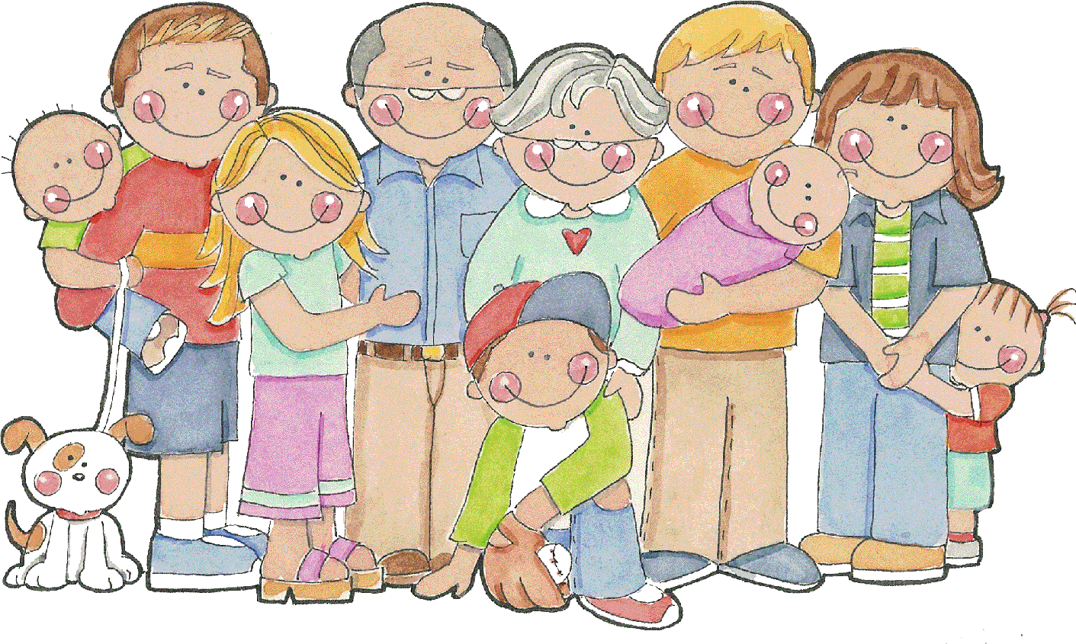[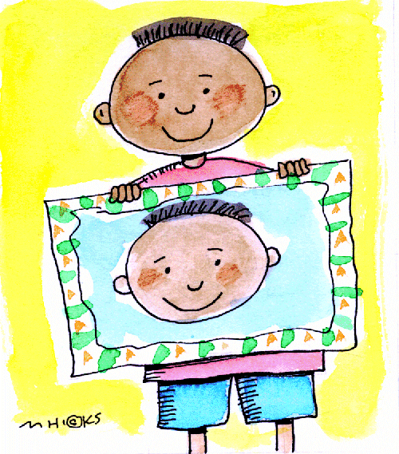](http://www.google.co.uk/url?sa=i&rct=j&q=&esrc=s&source=images&cd=&cad=rja&uact=8&ved=0ahUKEwidnOz6_JLVAhWCaxQKHa2JC3UQjRwIBw&url=http://www.clipartpanda.com/categories/self-portrait-clipart&psig=AFQjCNGYjAuS34jZMYDcvuWmPzWvV4aO_A&ust=1500472272954315)[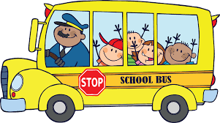](https://www.google.co.uk/url?sa=i&rct=j&q=&esrc=s&source=images&cd=&cad=rja&uact=8&ved=0ahUKEwjpmPbk69HJAhUBERQKHQCHBocQjRwIBw&url=http://www.clipartbest.com/free-clip-art-of-bus-for-children&bvm=bv.109395566,d.d24&psig=AFQjCNGcif9he8lLt_UukJBT3C8VY6IwKA&ust=1449855761379828)

**Education for Social Responsibility (ESR)**

* **To explore how kindness affects people around us**
* **To recognise ways, we can be kind to others**
* **To understand how we can be kind to other people in our community as well as our family and friends.**

**Physical Development**

**PE**

**We will be...**

* Practising getting changed for PE independently
* Developing our gross motors skills and negotiating space safely
* Developing ball skills- rolling, aiming and throwing
* Dance- responding to a piece of music
* Discussing the changes to our bodies after exercise
* Discussing the importance of staying active and exercising and trying lots of healthy snacks.
* Enhancing our fine motor control through threading, cutting, writing and drawing activities
* Using a range of tools when using malleable materials such as play dough and clay

**Understanding the World**

**Science/ History/ Geography/ RE**

**We will be...**

* Naming external parts of the body e.g. arm, leg, head, foot etc.
* Exploring the five senses
* **Looking at animals- habitats, classifying into groups**
* **Talking about how we have changed from birth to now**
* Looking at the similarities and differences between ourselves and others
* **Looking at how Toys have changed over time**
* The story of Guy Fawkes
* Explore the local area- look at maps/ seasons. Visit the Richard Jefferies Museum
* The story of Rama and Sita- Linked to the festival Diwali
* Bible Stories- The Nativity, The Calming of the storm, David and Goliath and Two Sons.

**Expressive Arts and Design**

**Art and Design Technology**

**We will be...**

* Using construction toys to build models.
* Using our imagination in role play situations.
* Expressing ourselves through paintings- self-portraits in various styles and using different media- paint, pens, chalk
* Learning the names of some percussion instruments and how to hold/play them correctly
* Learning and sing a variety of songs.
* Making Diva lamps out of clay
* Making Pop up Christmas cards

**Forest School**

* Taking part in National Forest School Day- 8th Oct 2021- make bird feeders, natural collages, den building, painting using ‘natural’ paintbrushes, campfire, and popcorn!
* Learning how to wattle and daub the willow roundhouse
* Making pictures using loose parts- portraits using natural objects such as leaves, pinecones, shells, pebbles, conkers
* Taking care of our school grounds
* Going on minibeast/ wildlife hunts

**Mathematics**

**We will be...**

* Looking for numbers in the environment and beginning to recognise numbers 0-10/ **20**
* **Understanding the place value of numbers**
* Beginning to represent some numbers using marks on paper, pictures and objects
* **Addition and Subtraction with numbers to 10**
* To join in with number rhymes and songs
* To be able to count out up to 10 objects and match to the correct numeral
* To develop their problem solving skills through a range of sorting, matching and pattern making activities

**Cherry, Ash & Oak Tree**

**Term 1 & 2: 2021**

**‘‘Being Kind to You and Me”**

***(Specific Year 1 objectives)***

**Literacy**

**We will be...**

* Learning to recognise and write my name
* Making marks using crayon, chalk, pencil, paint and explain what they say/ mean
* Taking part in ‘Phase 2’ and **‘Phase 3’** Storytime phonic sessions- learning the sounds that different letters make
* Segmenting and blending words when reading
* **Poetry- Friendship recipe**
* **Learning to sequence stories- Rama and Sita linked to Diwali**
* **Writing character descriptions**
* **Letter writing**

**Communication and Language**

**Speaking and Listening**

**We will be...**

* Learning to talk about ourselves using words such as tall, short etc.
* Imagining and recreating roles in the home role play area
* Asking questions to get to know our new friends
* Talking about our family and why they are special to us
* Thinking about sequence of events in stories and saying what happened in the beginning, middle and end.
* Singing songs
* Discussing what good listening looks like
* Following instructions and directions
* Asking and answering questions

**Personal, Social and Emotional development Personal, Social, Health and Economic**

**We will be…**

* Settling into the classroom routines and learning to separate from our carer at the beginning of the day
* Learning how to express our needs and feelings in an appropriate way
* Discussing our likes and dislikes
* Trying out new activities independently and selecting resources independently
* Developing an understanding of the classroom/ school rules
* Learning to think about the feelings of others
* Developing good relationships with our peers, playing co-operatively and sharing
* Talking about our family/ people who are important to us
* Thinking about special occasions/events to my family

[](https://www.google.co.uk/url?sa=i&rct=j&q=&esrc=s&source=images&cd=&cad=rja&uact=8&ved=0ahUKEwjpmPbk69HJAhUBERQKHQCHBocQjRwIBw&url=http://www.clipartbest.com/free-clip-art-of-bus-for-children&bvm=bv.109395566,d.d24&psig=AFQjCNGcif9he8lLt_UukJBT3C8VY6IwKA&ust=1449855761379828)